Add a test tool, here is go.bat

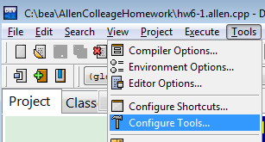

Press button ‘Add’

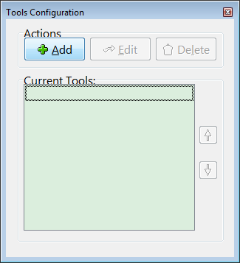

Type the test as followings:

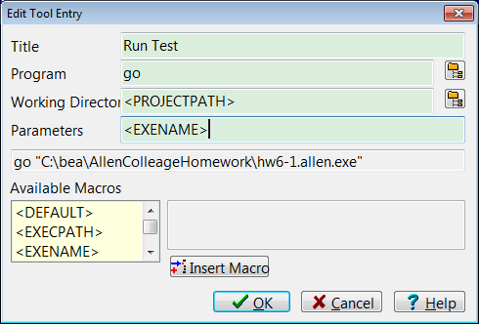

How to check the program result

* Prepare the input test file: that is <program name>.test  
  For example: if your program is hw6-1.cpp, then create a file named hw6-1.test at the same directory with hw6-1.cpp  
  
* Press ‘F9’ to compile the program
* Click Tools / Run Test to examine the program output

